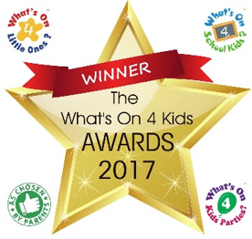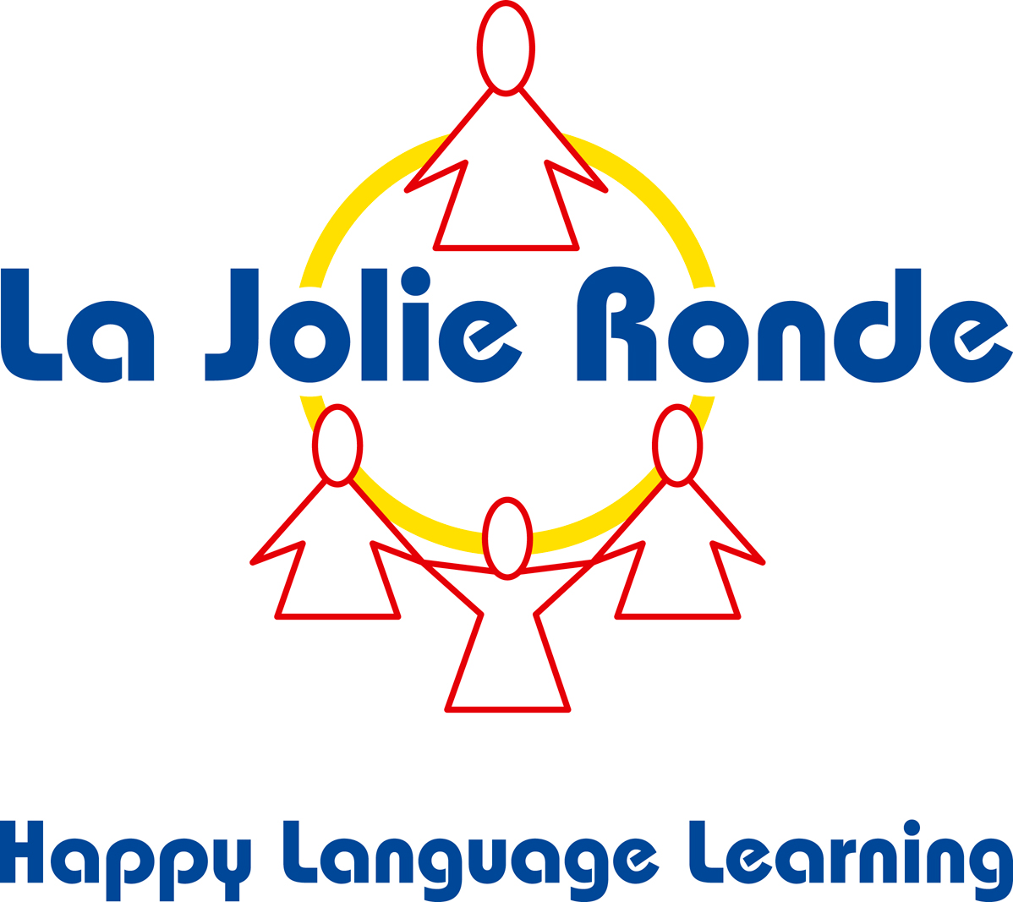

Booking form

Classes will take place on Wednesday lunch time. They are £6 per session plus the cost of the book £16 ( £ 88 in total for the Autumn term) payable by bank transfer before the start of the lessons. There will be 12 classes in the Autumn Term.

To book your child’s place, please complete and return this form. Confirmation of your booking will be sent to you by email. If you have any queries, please don’t hesitate to contact me

(Beata Kovacs: [french.beata@gmail.com/](mailto:french.beata@gmail.com/) 07525350516)

**Child’s Name**: **Date of Birth**:

**Parent(s)/Guardian(s) Name**:

**Telephone no**.:

**Emergency contact number**:

**Email:**

**Home Address**:

**Health Conditions & Allergies**

Please write any health conditions or allergies your child has below. If they have none, please write “NONE KNOWN” below.

Does your child have any special educational needs or disabilities which may affect their learning? **YES / NO**

*(If yes, I will email additional information for you in order to maximise your child’s learning experience. We do not discriminate on any grounds when accepting children into language classes).*

Please tick to confirm:

* My child does not have any food allergies and I give permission for him/her to be given any food you deem suitable.
* I give permission for my child’s photograph to be used on Social Media.
* ­­­­­­­­­­­­­­­­I give permission for my child’s photograph to be used for promotional purposes.
* I give permission for the tutor to seek medical advice or provide treatment in an emergency
* I have read and understood the terms and conditions given to me and agree to comply with them fully.
* I agree for my contact details to be used to inform me of other classes and services. I understand that I will be able to unsubscribe at any time. *(Your contact details will not be passed to any third parties)*

**Privacy policy**

All the personal information collected on this booking form is requested to operate the agreement between you and us. It will not be passed on to any third party and will be deleted when your child is no longer attending our classes.

**Signature**: **Date**: