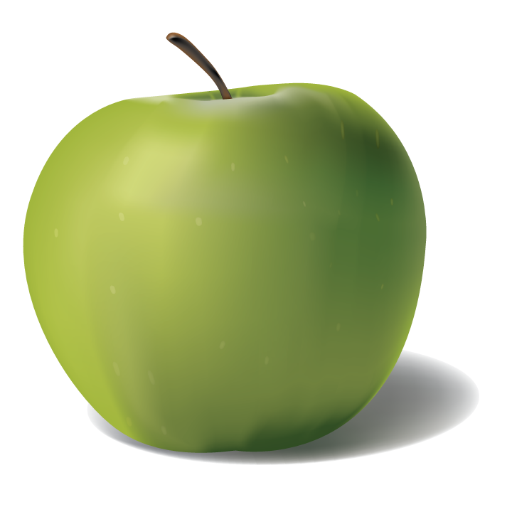
Healthy Living

Music
Taking off – exploring pitch
Indian Music

PE
Gymnastics
3 Tees cricket
Team Building
History
Significant individuals from the past - Famous nurses: Florence Nightingale and Mary Seacole
Changes in medicines and healthcare

Science
Animals including humans – survival needs, health and growth, life cycles, food groups.
Plants– Growing conditions for plants, growing different plants.

RE
What questions do religious stories make us ask? Can we find any answers?
How do Muslims belong to their faith family?

Christianity/Hindu/Islam

Art
Self-portraits – Making our own and looking at the work of Van Gogh, Archimboldo and Picasso.

PSHE
Physical Health and Mental Wellbeing
Why sleep is important, medicines, keeping healthy, keeping teeth healthy, managing feelings and asking for help.
Keeping Safe
Safety in different environments, risk and safety at home, emergencies.

Design Technology
Food packaging - Evaluating and designing a product
Preparing and cooking a healthy meal

Computing
Making digital music

Recording and presenting data
Geography
Investigating our local area and comparing it to a locality overseas – a journey through the USA

Maths
Properties of Shape - identify and describe the properties of 2-D shapes, including the number of sides and line symmetry in a vertical line. Identify and describe the properties of 3-D shapes, including the number of edges, vertices and faces. Identify 2-D shapes on the surface of 3-D shapes, [for example, a circle on a cylinder and a triangle on a pyramid]. Compare and sort common 2-D and 3-D shapes and everyday objects.
Multiplication and Division - Recall and use multiplication and division facts for the 2, 5 and 10 multiplication tables, including recognising odd and even numbers. Show that multiplication of two numbers can be done in any order. Write using the symbols (x) multiplication , (÷) division and equals (=) signs Fractions Recognise, find and write fractions 1/3, ¼, 2/4 and ¾ of a length, shape, set of objects or quantity.
Money – Count money in pounds and pence (notes and coins), choose notes and coins to make the same amount e.g. £1, compare amounts of money, calculate with money, find change, two-step money problems.
Length and height – Measure in centimetres and metres, compare and order lengths and heights, addition, subtraction, multiplication and division with lengths and heights.
Mass, capacity and temperature – Compare mass, measure in grams and kilograms, compare volume and capacity, addition, subtraction, multiplication and division with mass, measure in millilitres and litres, addition, subtraction, multiplication and division with volume and capacity, temperature.

Topic web to show possible Year 2 activities for Spring Term
English
Fiction – Traditional Tales with a twist
Non-fiction – Instructions
– Discussions
Spelling, Punctuation and Grammar – learning about verbs, adding suffixes to words and associated spelling patterns, using the single possessive apostrophe and the apostrophe for omission; continuing to practise reading and writing Little Wandle tricky words and common exception words.
Reading Comprehension – learning more about and practising the skills of retrieval of information, prediction and inference in a range of texts of different genres.
Phonics – Consolidation of all phases; building on application in reading and writing.

